RFQ BINYAH

Home - Personal - Microsoft​ Edge

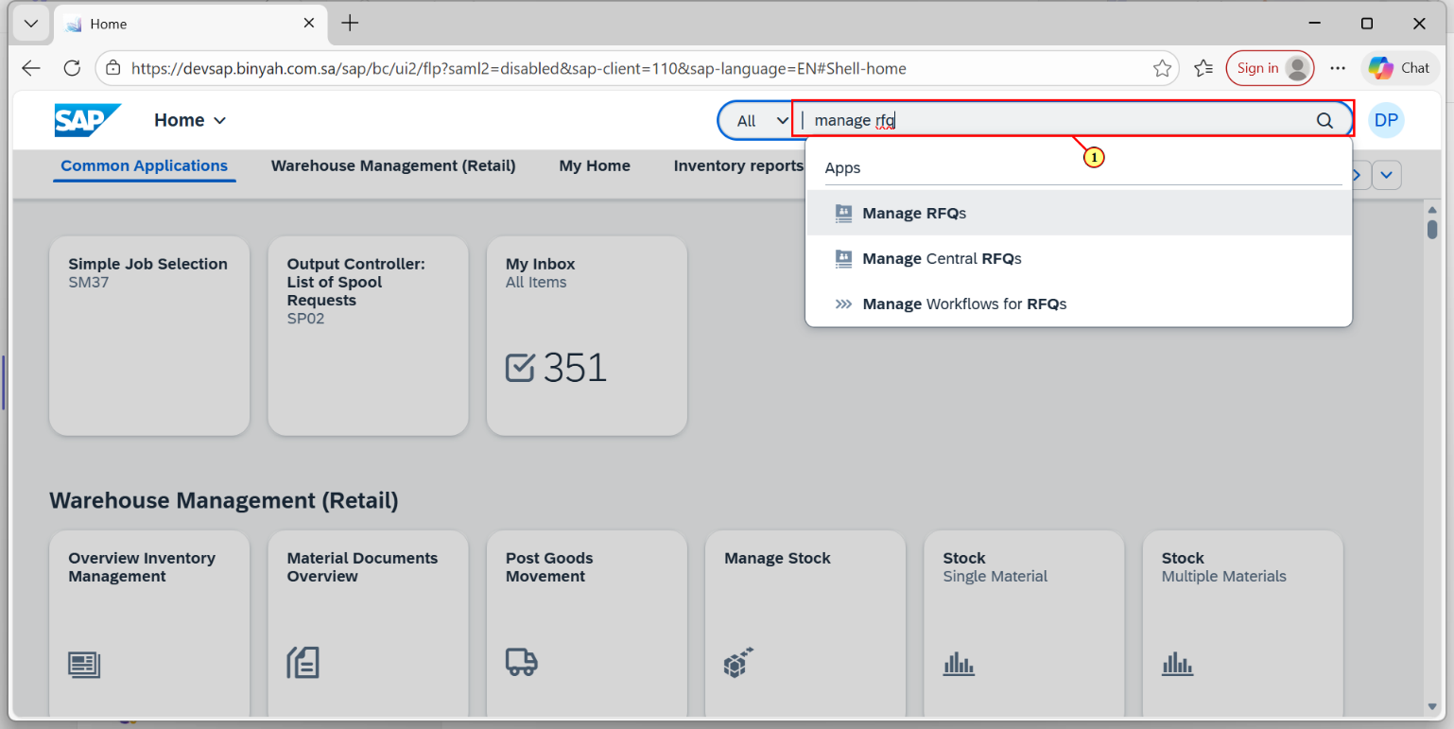

| Step | Action |
| --- | --- |
| (1) | Search and Open "Manage RFQs". |

Manage RFQs - Personal - Microsoft​ Edge

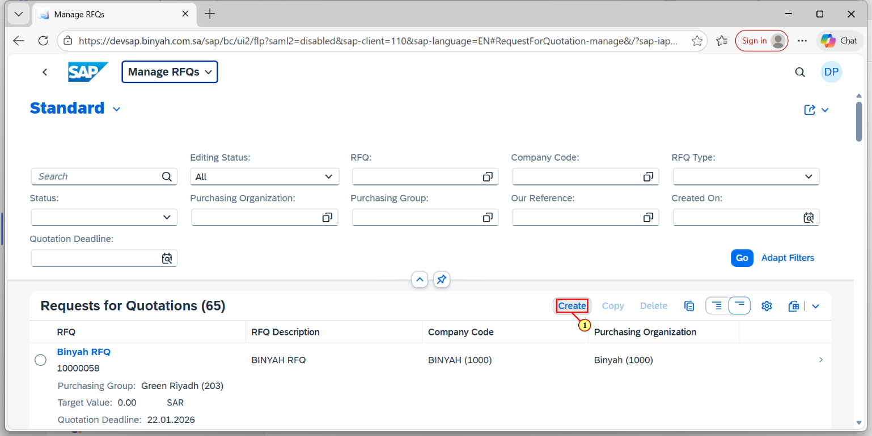

| Step | Action |
| --- | --- |
| (1) | Click on "Create". |

Manage RFQs - Personal - Microsoft​ Edge

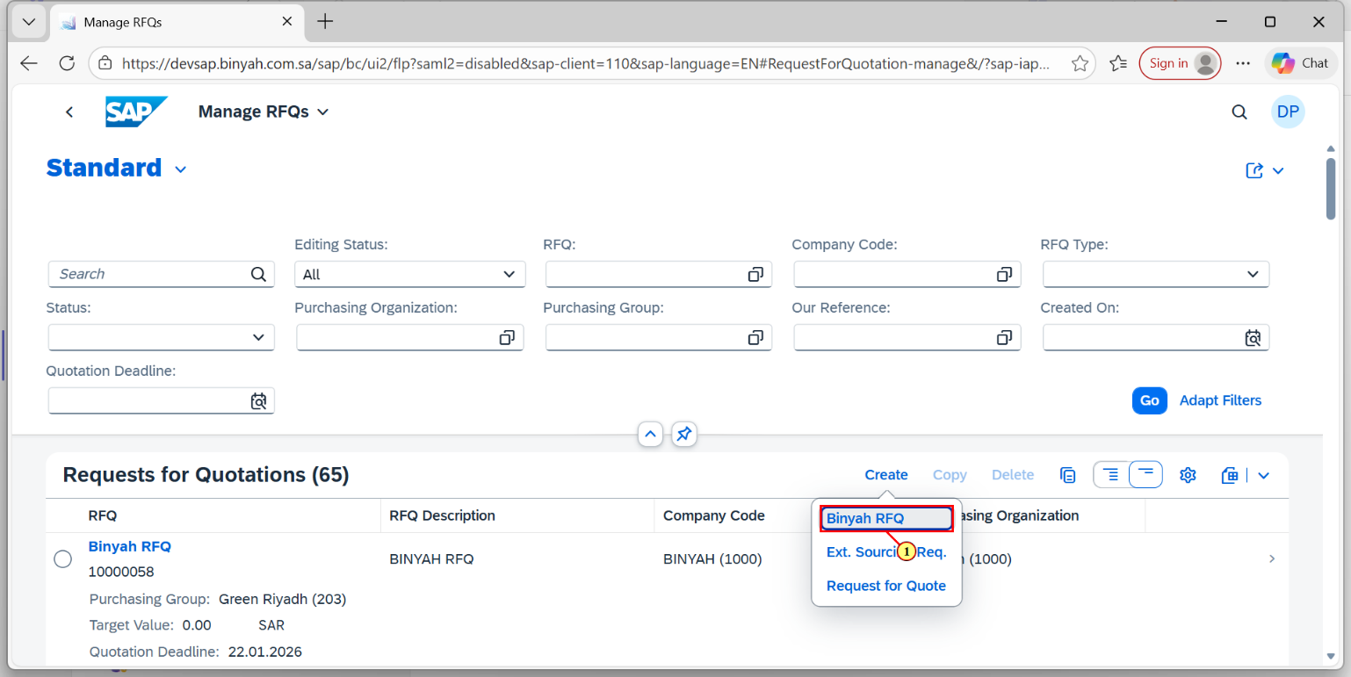

| Step | Action |
| --- | --- |
| (1) | Click on "Binyah RFQ". |

Request for Quotation - Personal - Microsoft​ Edge

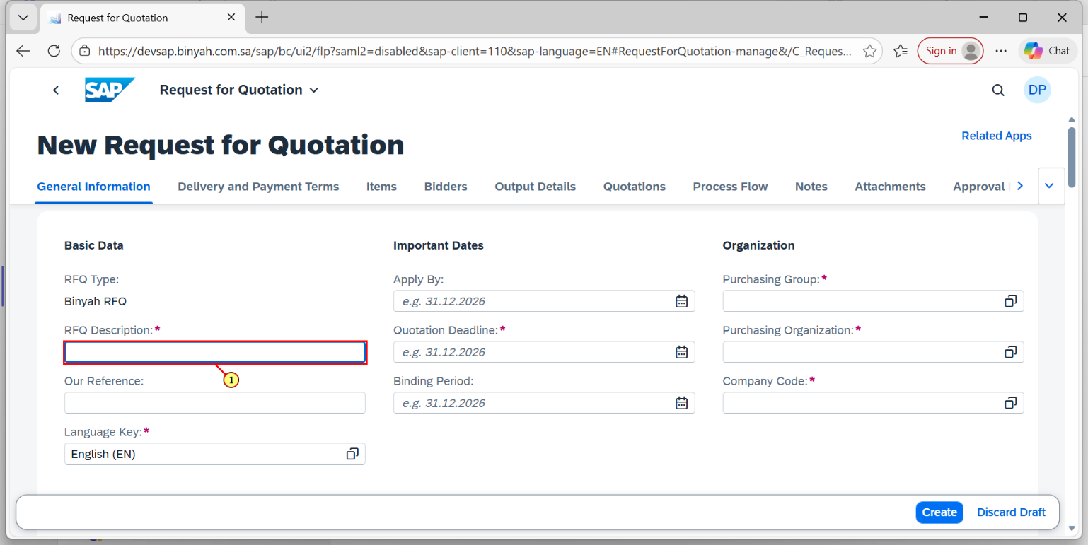

| Step | Action |
| --- | --- |
| (1) | Enter "RFQ Description". |

Request for Quotation - Personal - Microsoft​ Edge

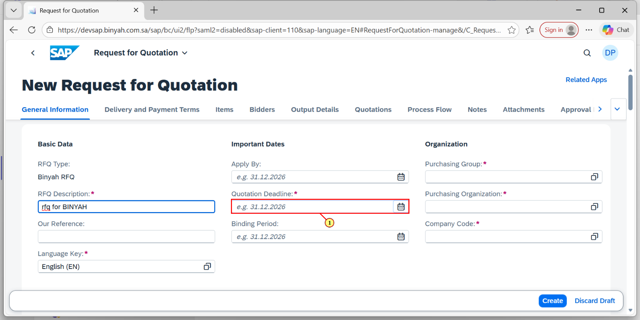

| Step | Action |
| --- | --- |
| (1) | Select Submission Deadline. |

Request for Quotation - Personal - Microsoft​ Edge

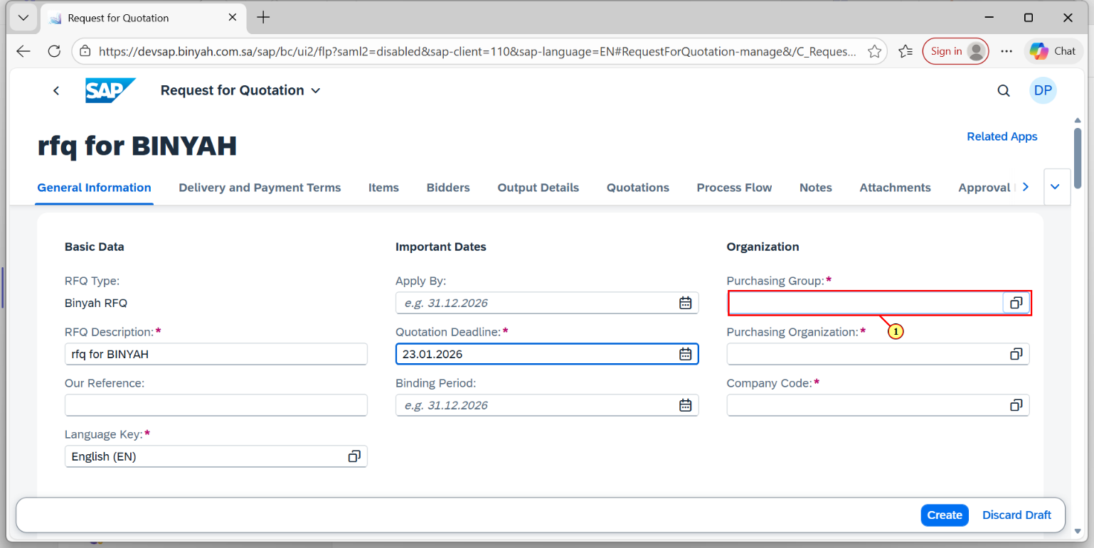

| Step | Action |
| --- | --- |
| (1) | Enter "Purchasing Group". |

Request for Quotation - Personal - Microsoft​ Edge

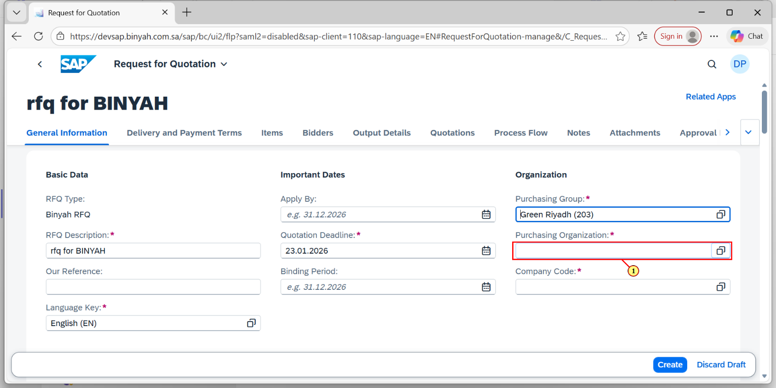

| Step | Action |
| --- | --- |
| (1) | Enter "Purchasing Organization". |

Request for Quotation - Personal - Microsoft​ Edge

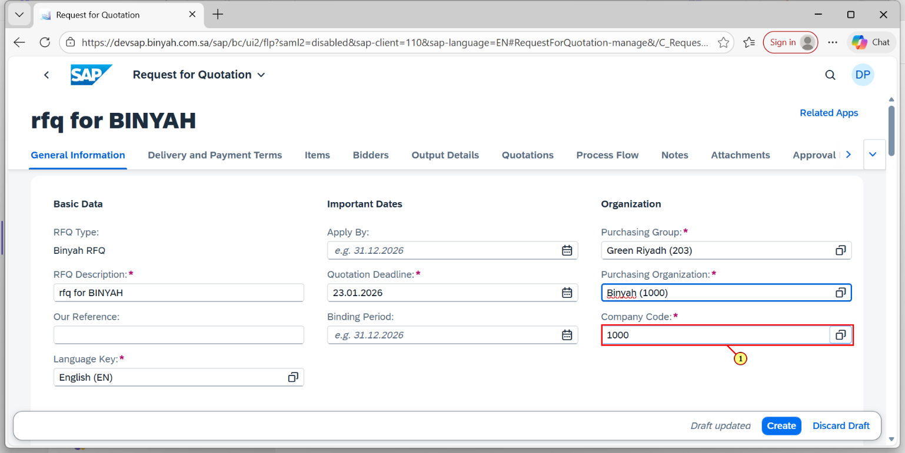

| Step | Action |
| --- | --- |
| (1) | Enter "Company Code". |

Request for Quotation - Personal - Microsoft​ Edge

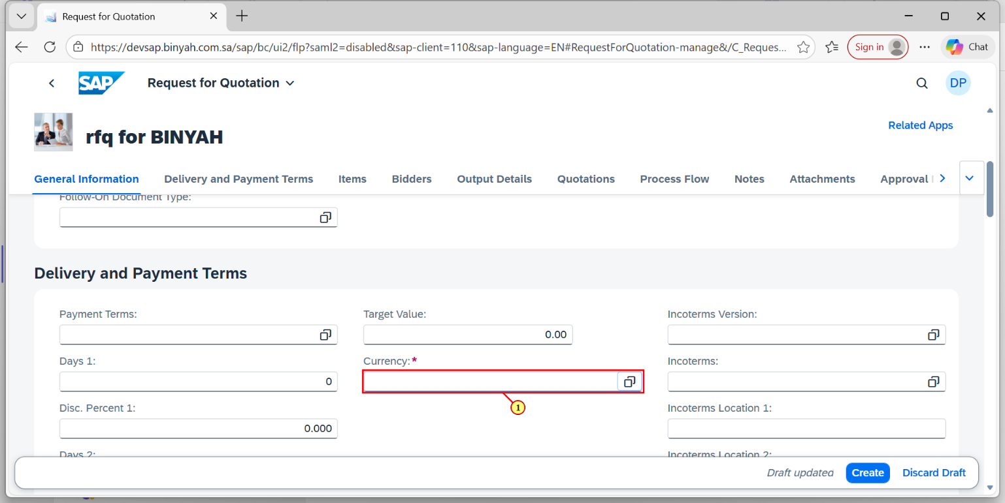

| Step | Action |
| --- | --- |
| (1) | Enter "Currency". |

Request for Quotation - Personal - Microsoft​ Edge

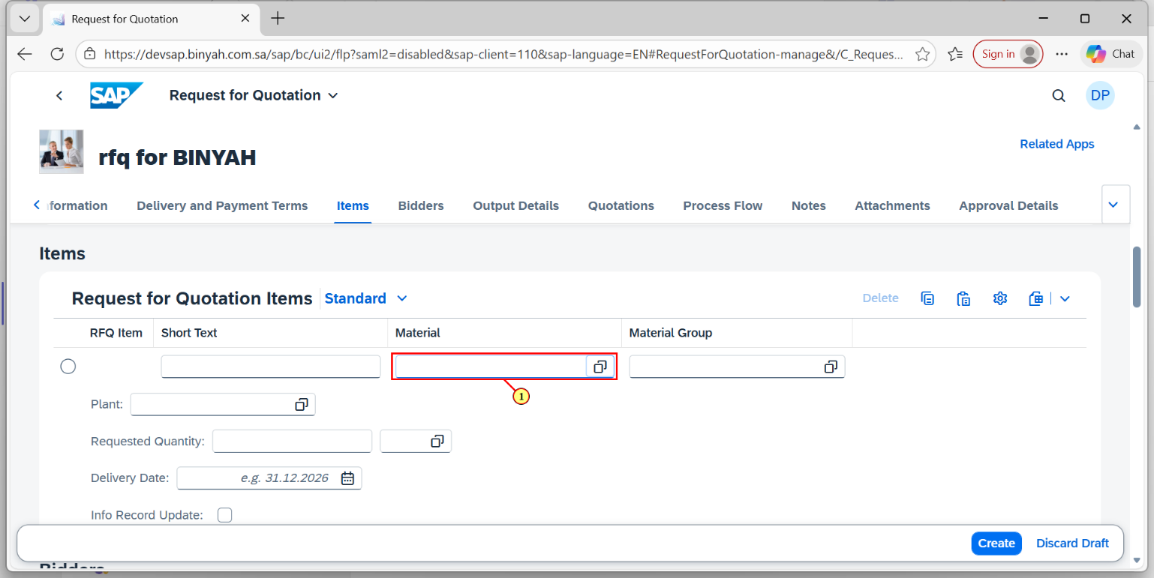

| Step | Action |
| --- | --- |
| (1) | In Item Section, Enter "Material". |

Request for Quotation - Personal - Microsoft​ Edge

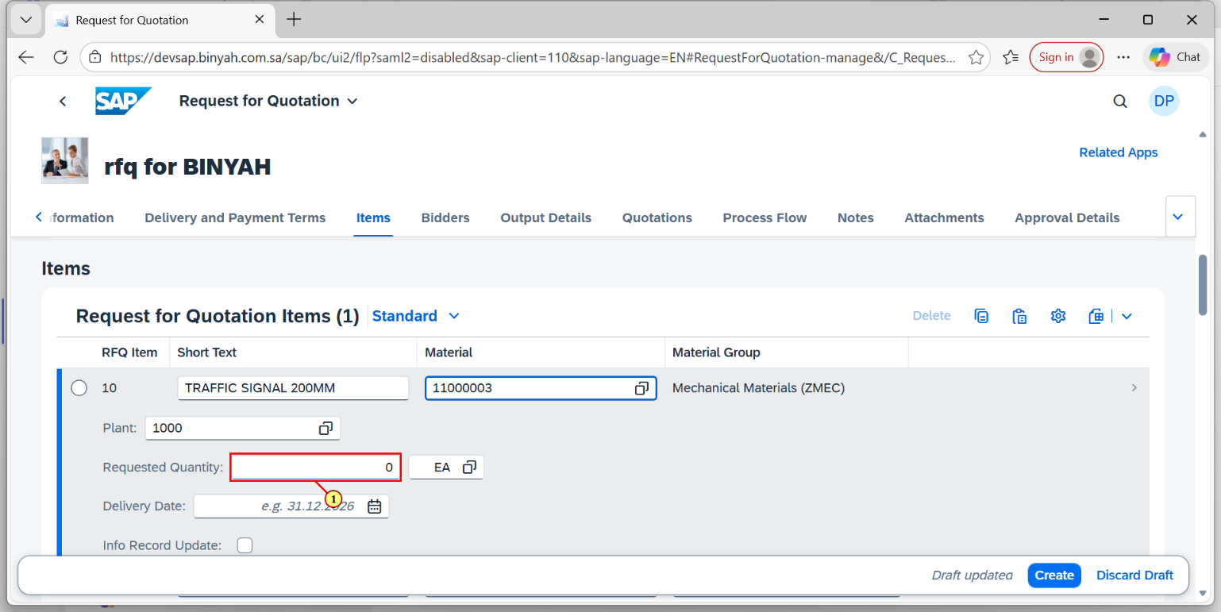

| Step | Action |
| --- | --- |
| (1) | Enter "Quantity". |

Request for Quotation - Personal - Microsoft​ Edge

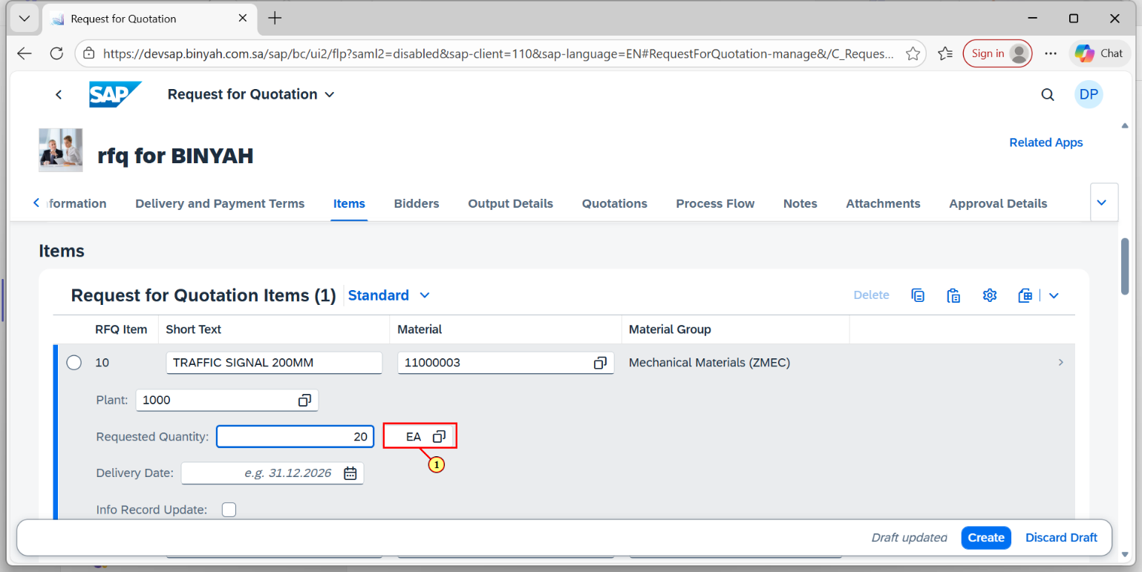

| Step | Action |
| --- | --- |
| (1) | Enter "Unit of Measure". |

Request for Quotation - Personal - Microsoft​ Edge

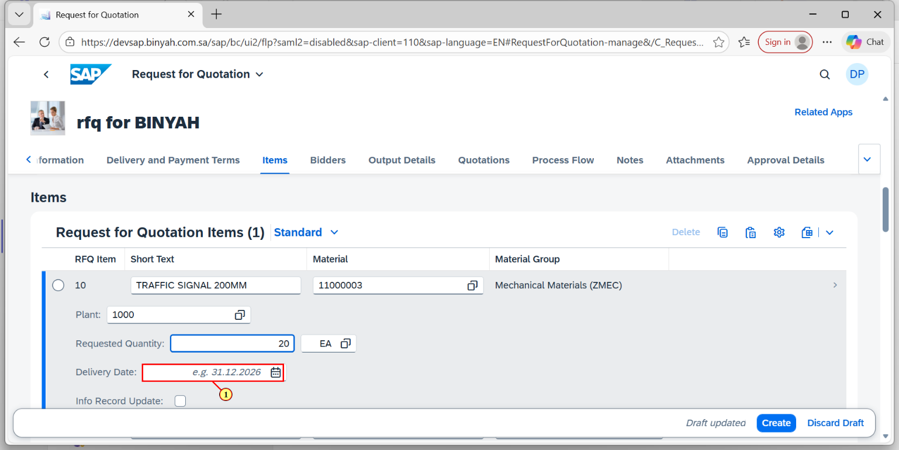

| Step | Action |
| --- | --- |
| (1) | Enter "Delivery Date". |

Request for Quotation - Personal - Microsoft​ Edge

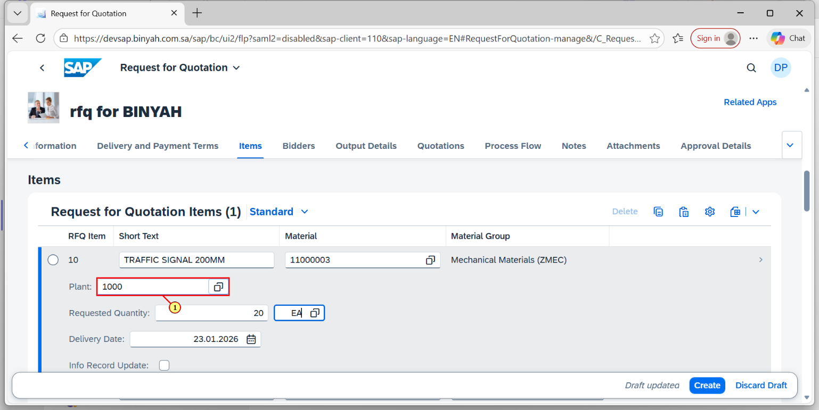

| Step | Action |
| --- | --- |
| (1) | Enter "Plant". |

Request for Quotation - Personal - Microsoft​ Edge

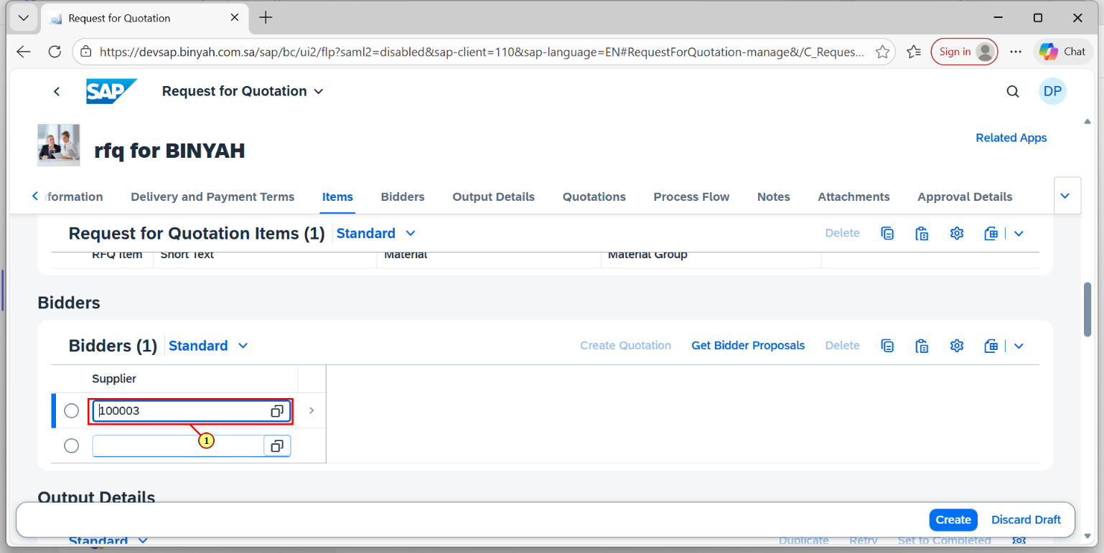

| Step | Action |
| --- | --- |
| (1) | In Bidders Section Enter "Supplier". |

Request for Quotation - Personal - Microsoft​ Edge

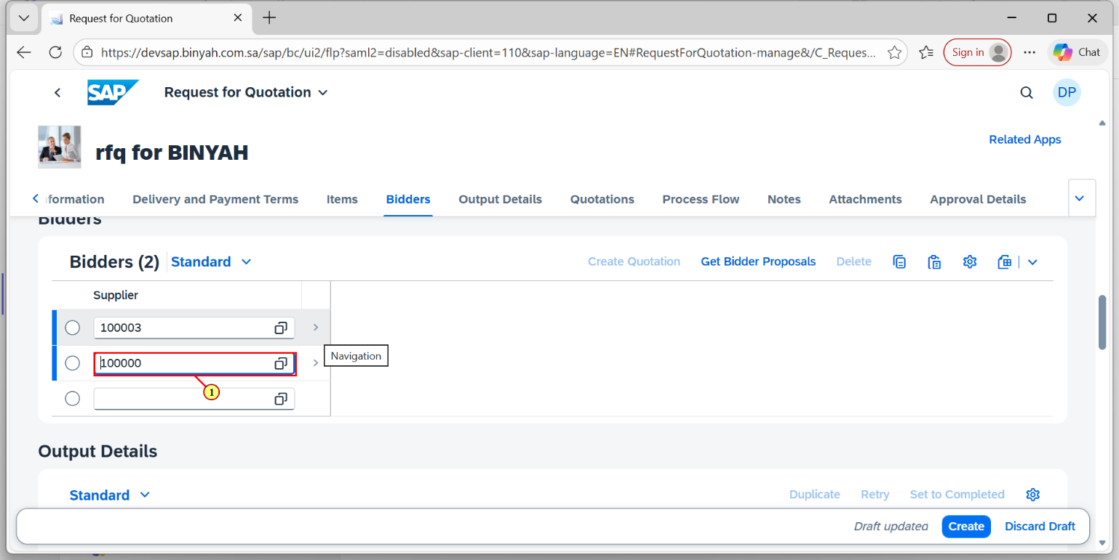

| Step | Action |
| --- | --- |
| (1) | Enter One more "Supplier". |

Request for Quotation - Personal - Microsoft​ Edge

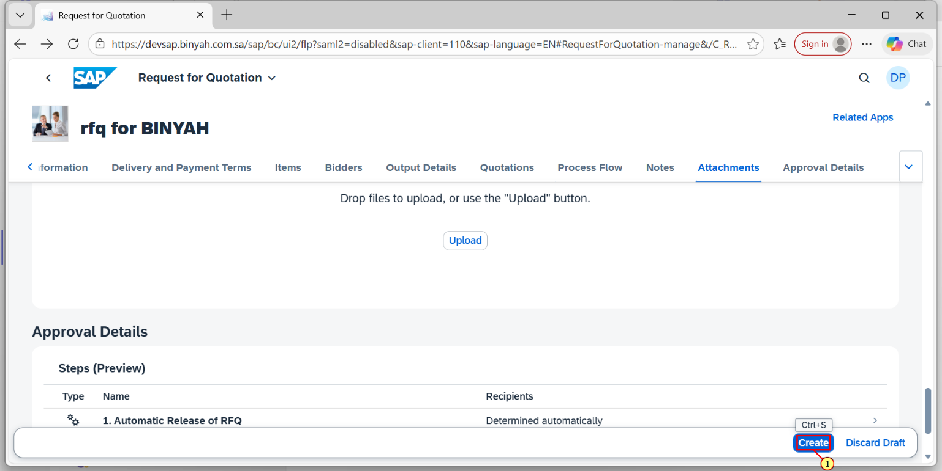

| Step | Action |
| --- | --- |
| (1) | Click on "Create". |

Request for Quotation - Personal - Microsoft​ Edge

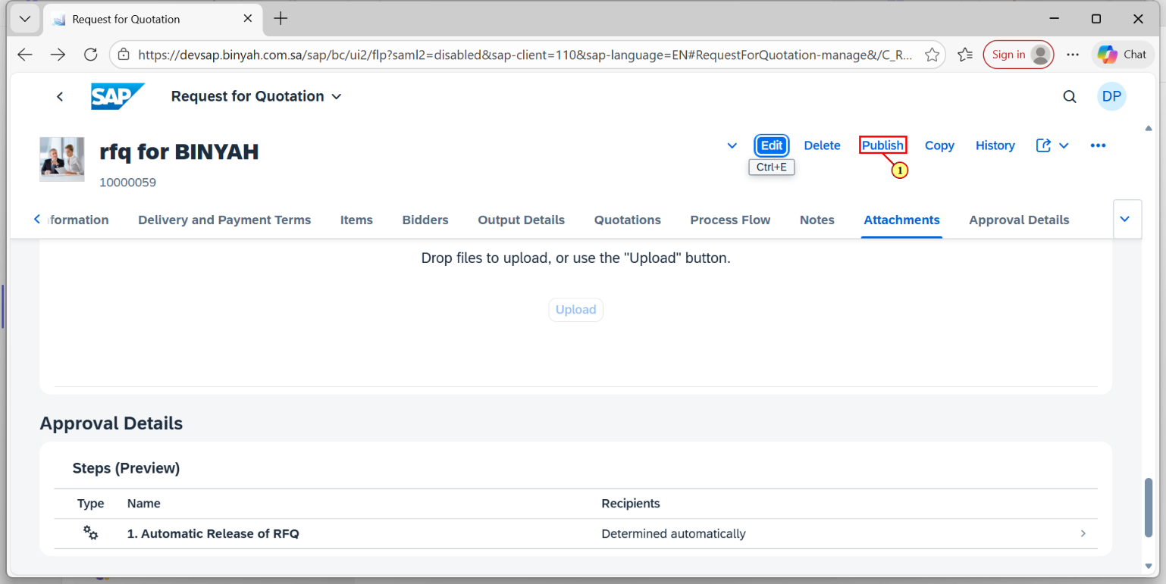

| Step | Action |
| --- | --- |
| (1) | Click on "Publish". |

Home - Personal - Microsoft​ Edge

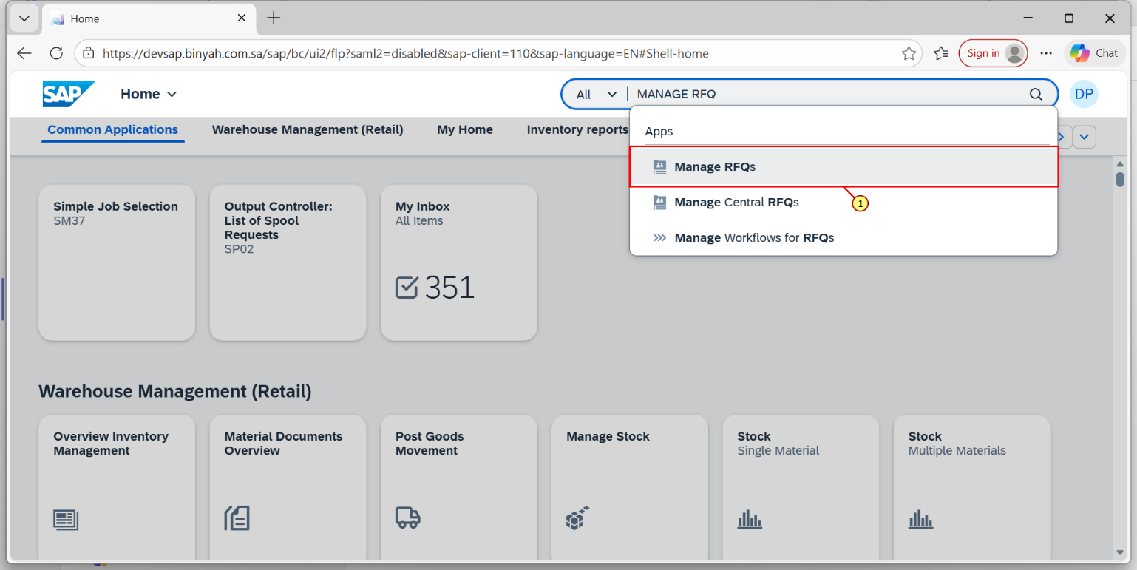

| Step | Action |
| --- | --- |
| (1) | Search and Open "Manage RFQs". |

Manage RFQs - Personal - Microsoft​ Edge

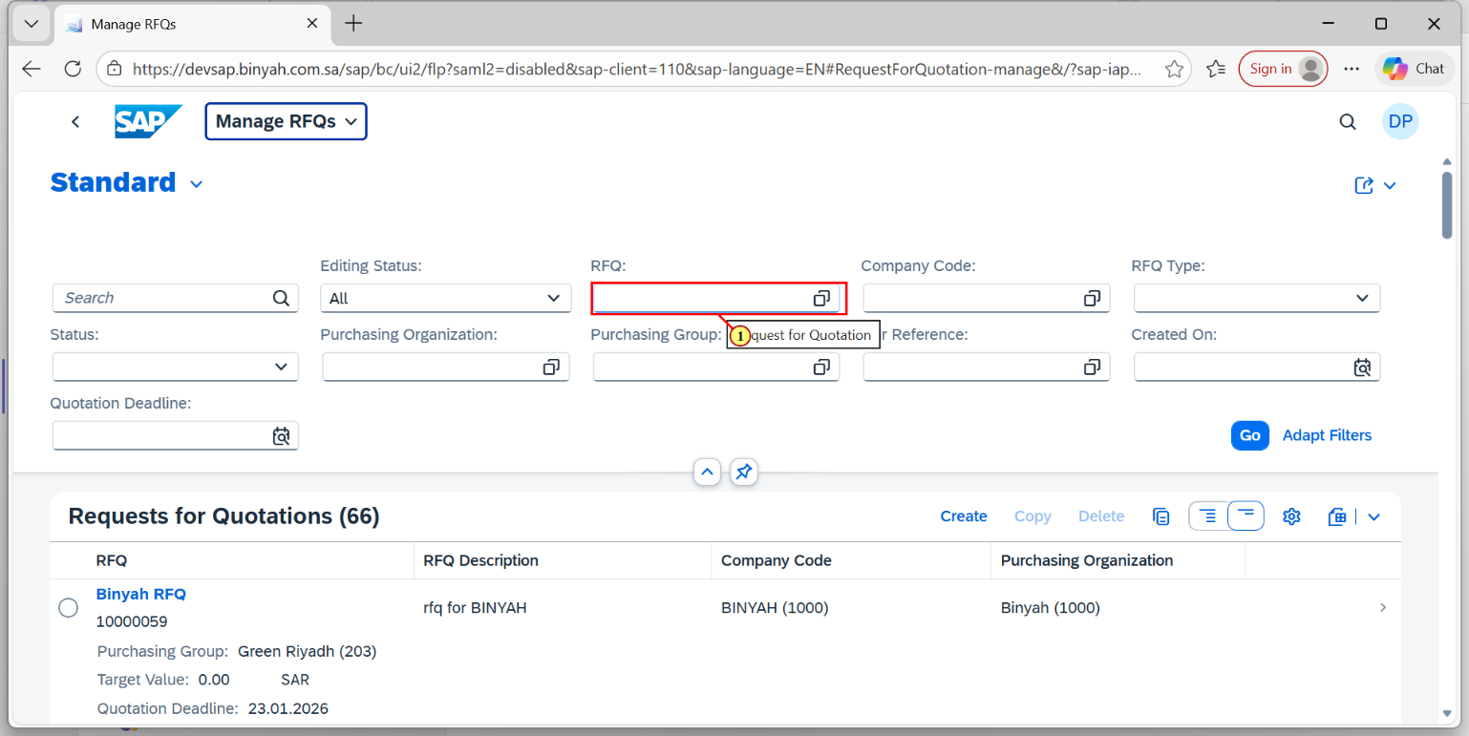

| Step | Action |
| --- | --- |
| (1) | Using Filter, Give the RFQ Number. |

Manage RFQs - Personal - Microsoft​ Edge

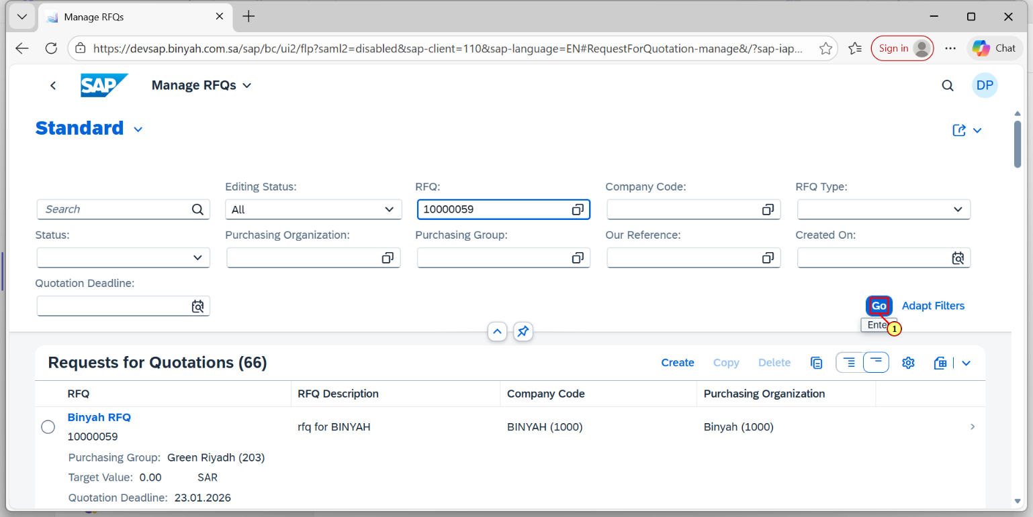

| Step | Action |
| --- | --- |
| (1) | Click on "GO". |

Manage RFQs - Personal - Microsoft​ Edge

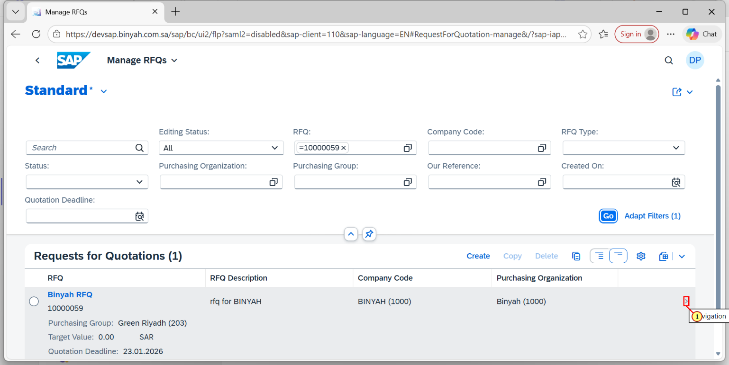

| Step | Action |
| --- | --- |
| (1) | Click the Navigation option in RFQ. |

Request for Quotation - Personal - Microsoft​ Edge

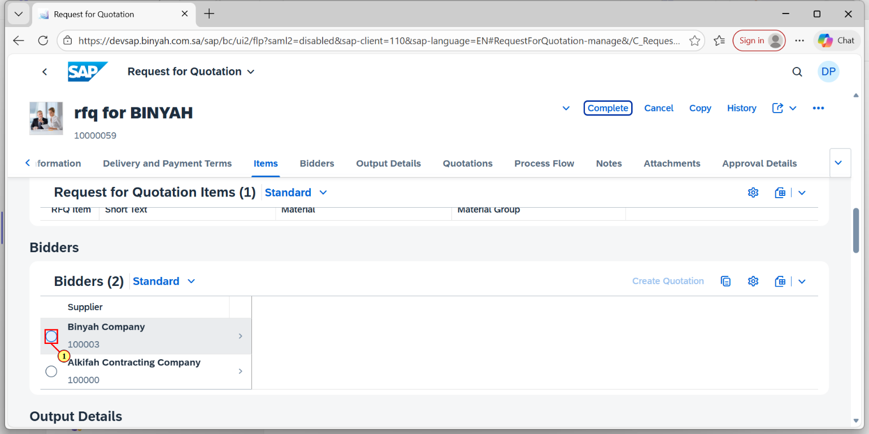

| Step | Action |
| --- | --- |
| (1) | In Bidders Section, Select the Bidder. |

Request for Quotation - Personal - Microsoft​ Edge

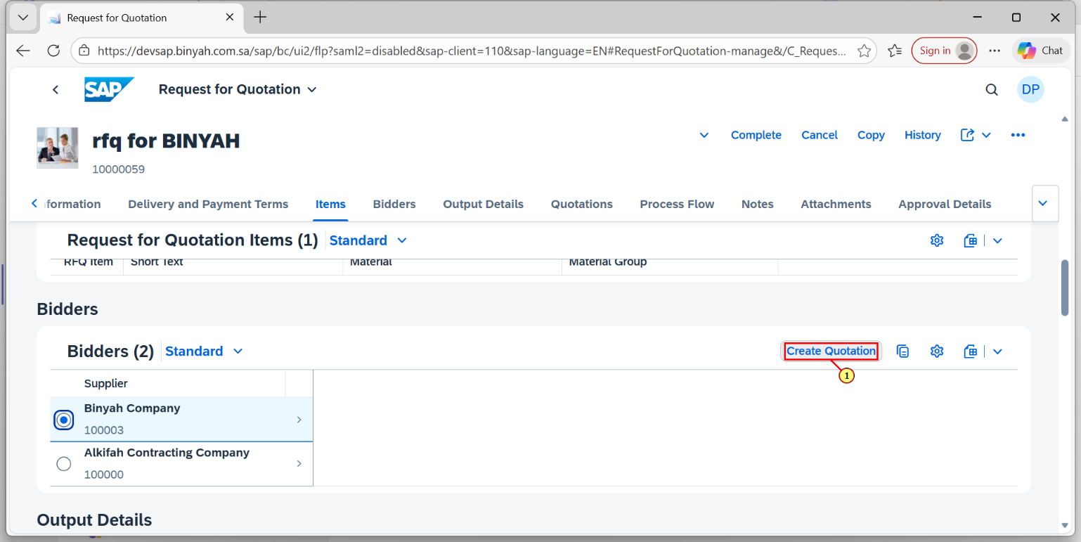

| Step | Action |
| --- | --- |
| (1) | Click on "Create Quotation". |

Supplier Quotation - Personal - Microsoft​ Edge

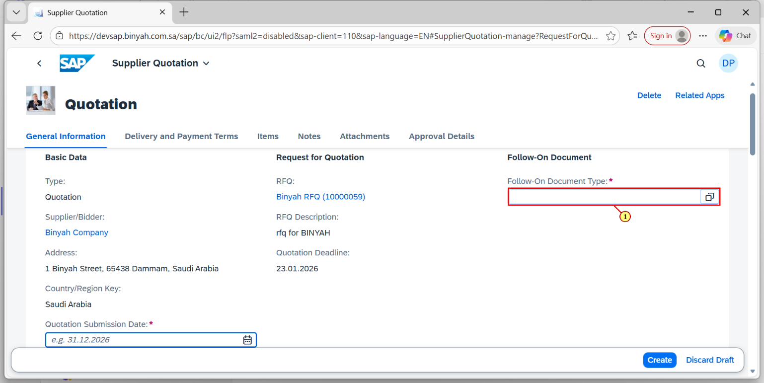

| Step | Action |
| --- | --- |
| (1) | Enter the Follow-On Document Type". |

Supplier Quotation - Personal - Microsoft​ Edge

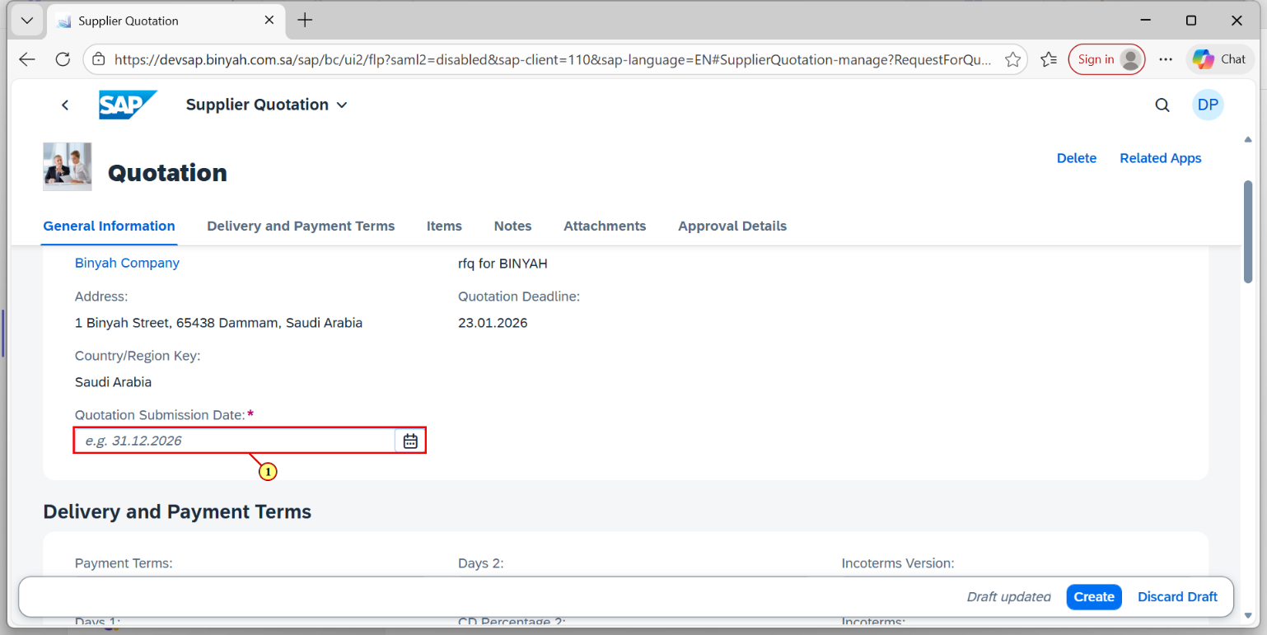

| Step | Action |
| --- | --- |
| (1) | Enter the "Quotation Submission Date". |

Supplier Quotation - Personal - Microsoft​ Edge

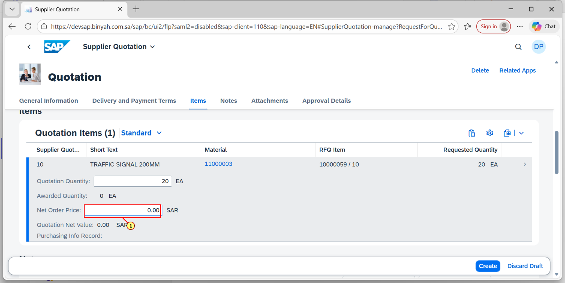

| Step | Action |
| --- | --- |
| (1) | Enter the "Net Order Price". |

Supplier Quotation - Personal - Microsoft​ Edge

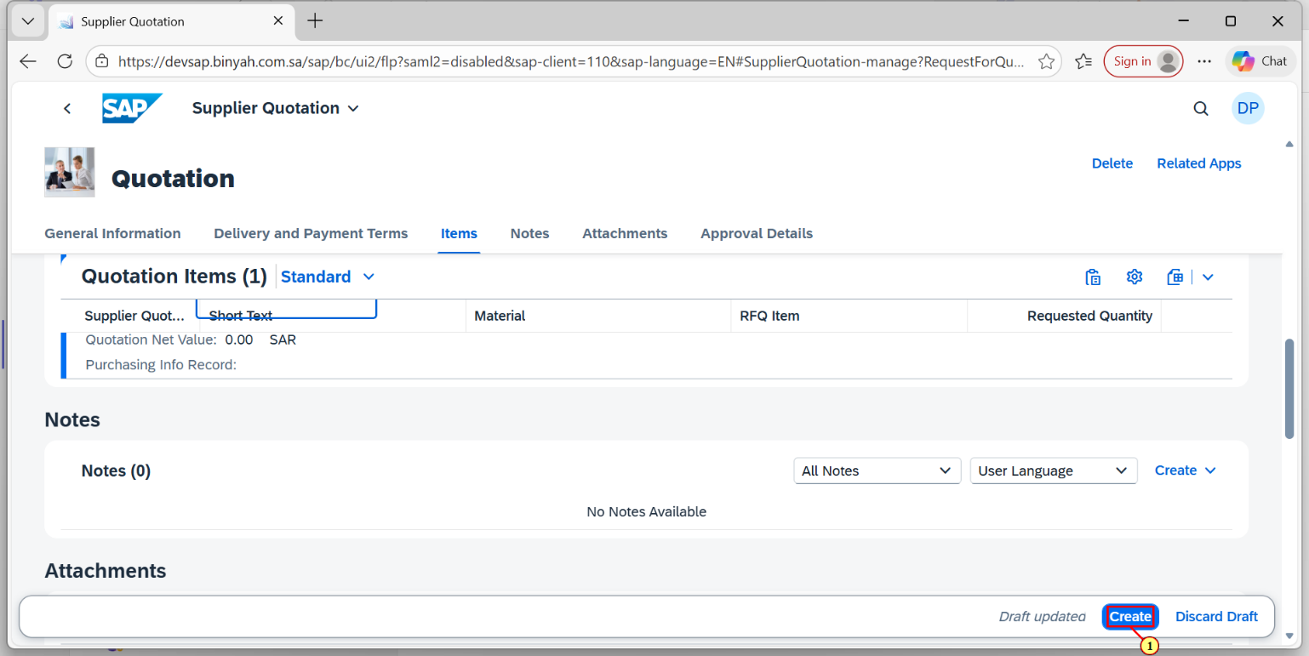

| Step | Action |
| --- | --- |
| (1) | Click on "Create". |

Request for Quotation - Personal - Microsoft​ Edge

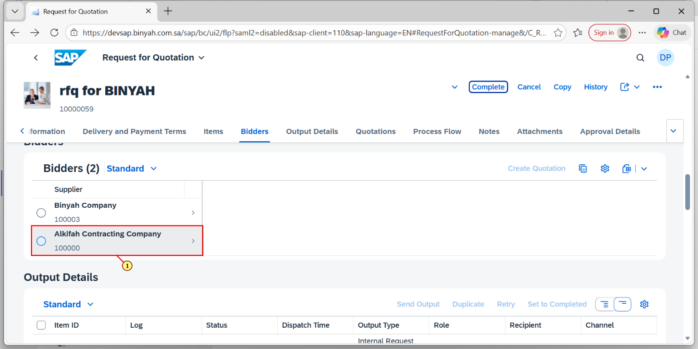

| Step | Action |
| --- | --- |
| (1) | Click on Another Supplier. |

Request for Quotation - Personal - Microsoft​ Edge

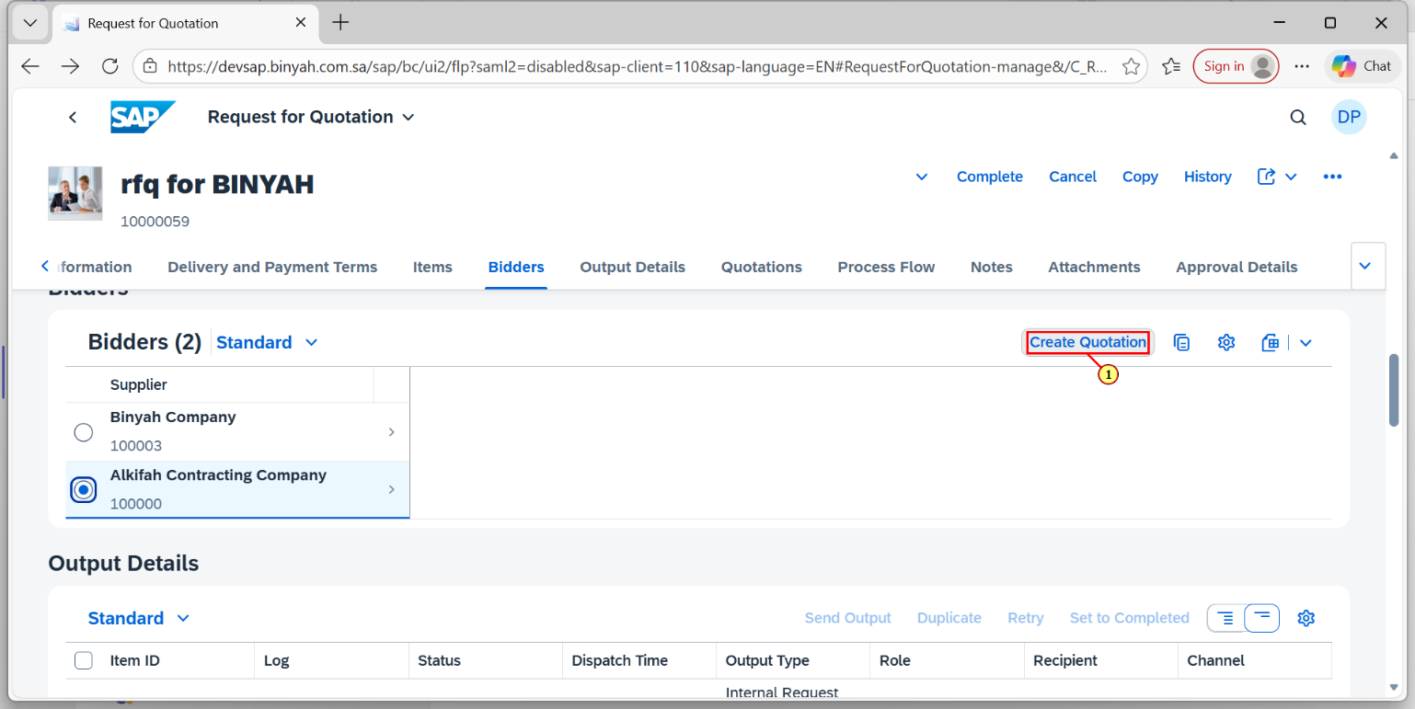

| Step | Action |
| --- | --- |
| (1) | Click on "Create Quotation". |

Supplier Quotation - Personal - Microsoft​ Edge

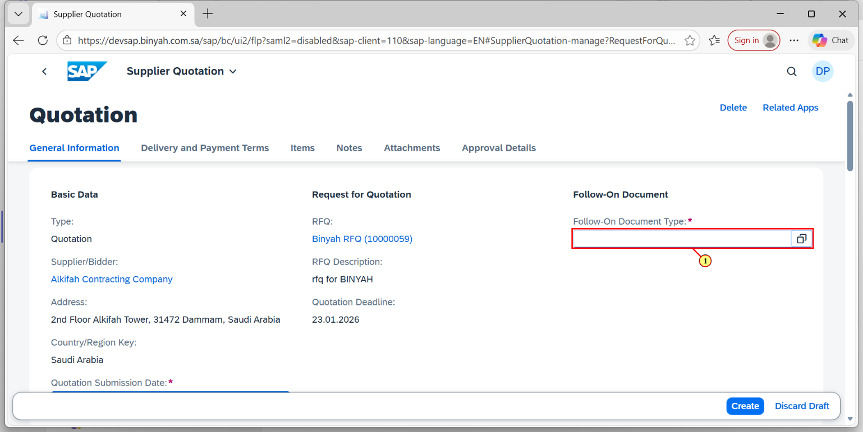

| Step | Action |
| --- | --- |
| (1) | Enter the Follow-On Document Type". |

Supplier Quotation - Personal - Microsoft​ Edge

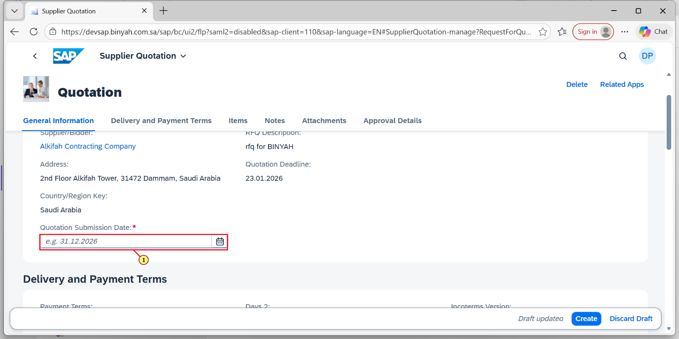

| Step | Action |
| --- | --- |
| (1) | Enter the "Quotation Submission Date". |

Supplier Quotation - Personal - Microsoft​ Edge

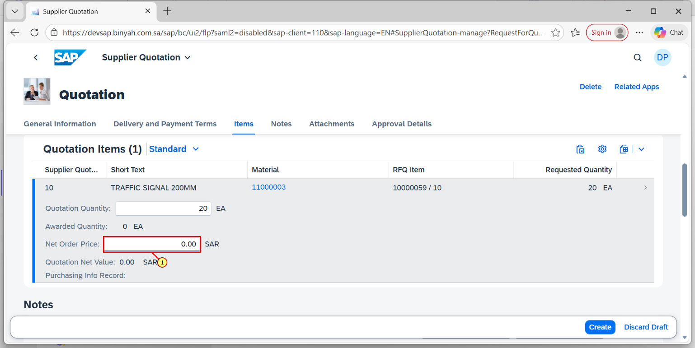

| Step | Action |
| --- | --- |
| (1) | Enter the "Net Order Price". |

Request for Quotation - Personal - Microsoft​ Edge

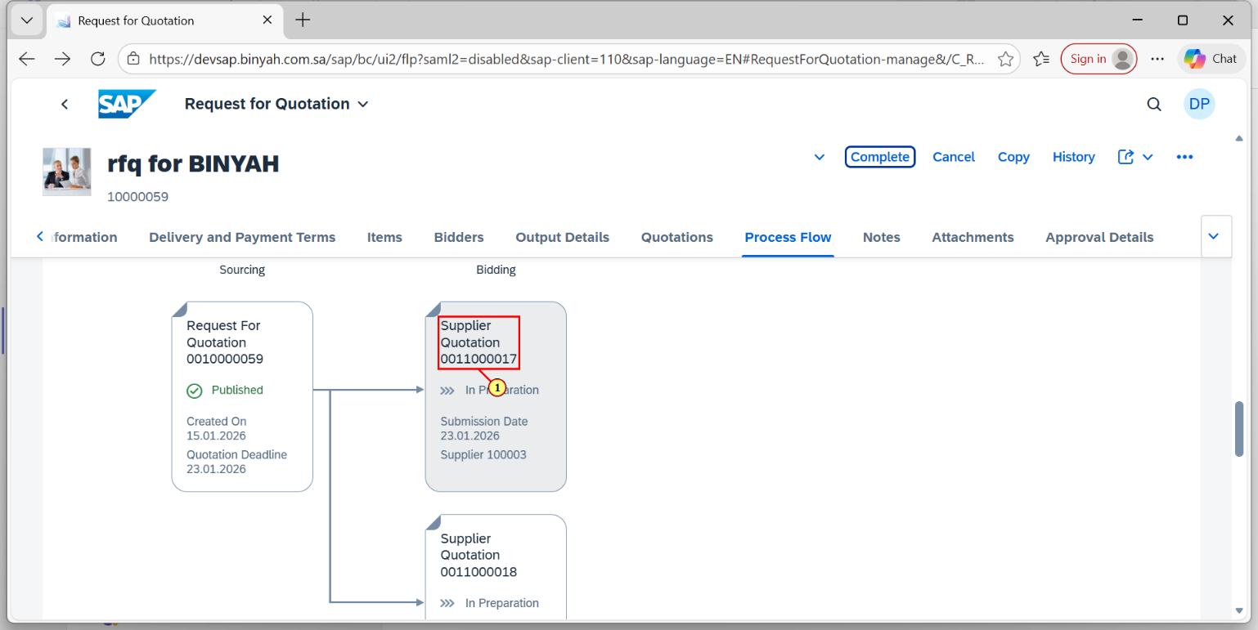

| Step | Action |
| --- | --- |
| (1) | In Process Flow Section, Click on Supplier. |

Supplier Quotation - Personal - Microsoft​ Edge

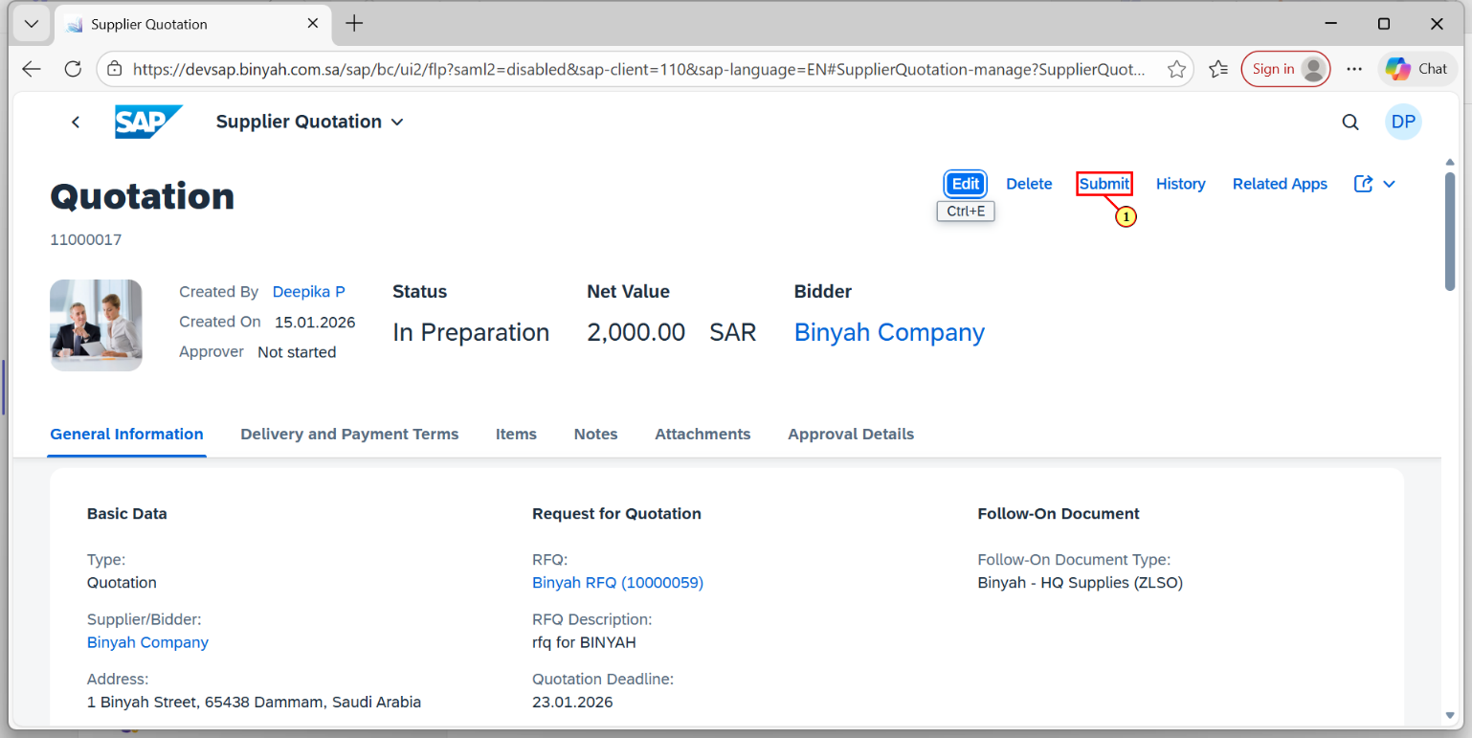

| Step | Action |
| --- | --- |
| (1) | It will Navigate to Another page. Here Click "SUBMIT". |

Request for Quotation - Personal - Microsoft​ Edge

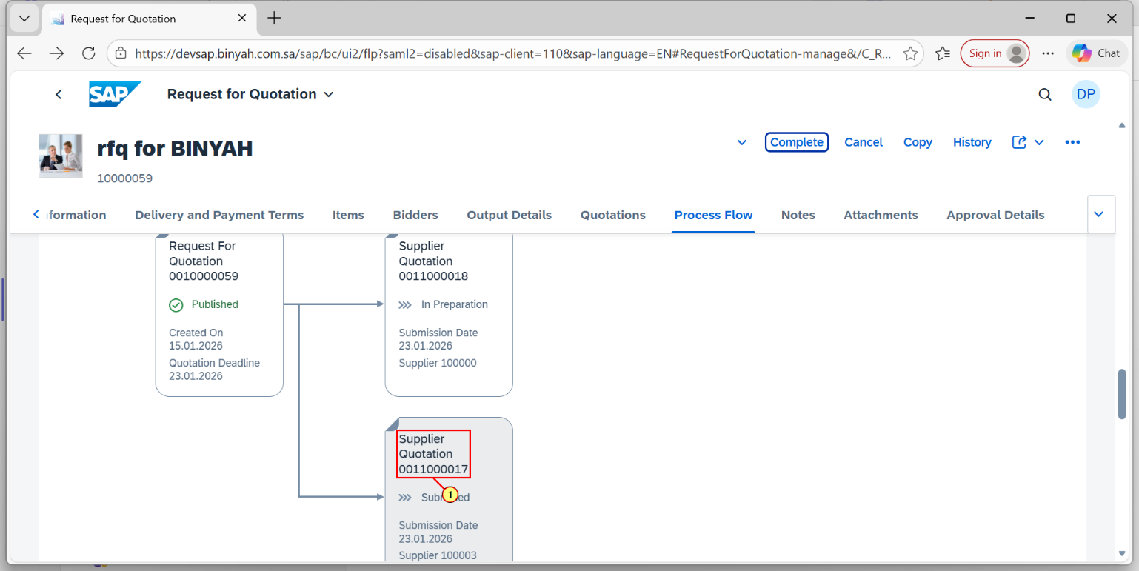

| Step | Action |
| --- | --- |
| (1) | Click on Another Supplier and Click on "Submit". |
|  |  |

Home - Personal - Microsoft​ Edge

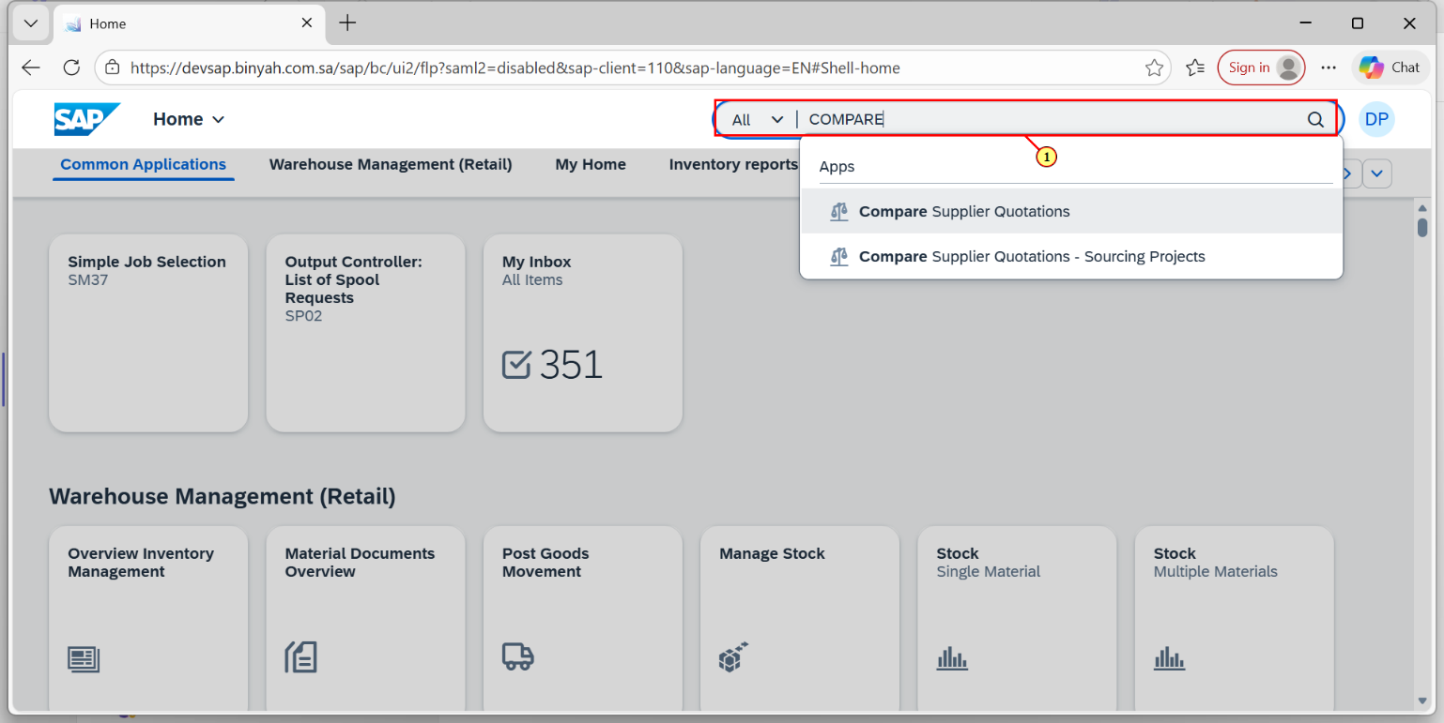

| Step | Action |
| --- | --- |
| (1) | Search and Open "Compare Supplier Quotations". |

Compare Supplier Quotations - Personal - Microsoft​ Edge

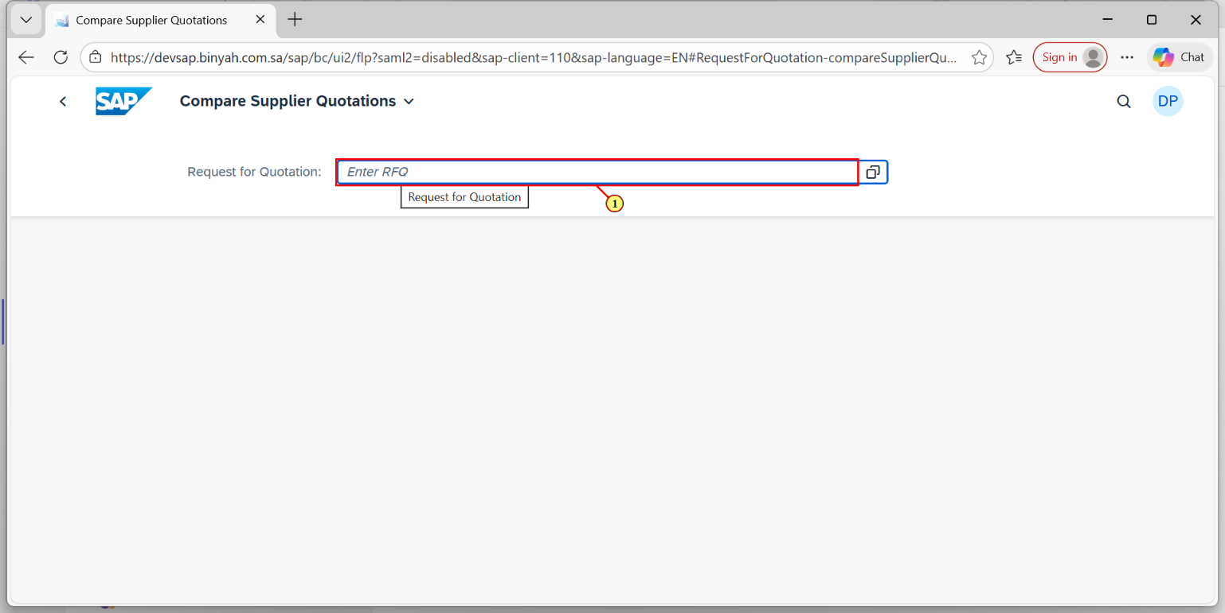

| Step | Action |
| --- | --- |
| (1) | Enter the RFQ Number and Click "Enter". |

Compare Supplier Quotations - Personal - Microsoft​ Edge

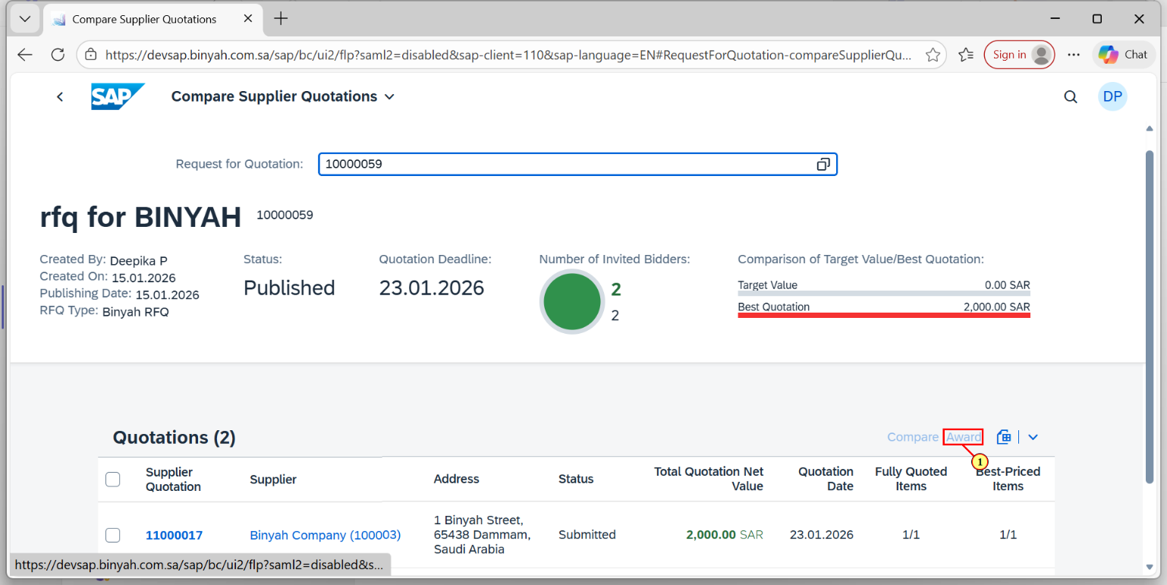

| Step | Action |
| --- | --- |
| (1) | Click "Award Button". |

Home - Personal - Microsoft​ Edge

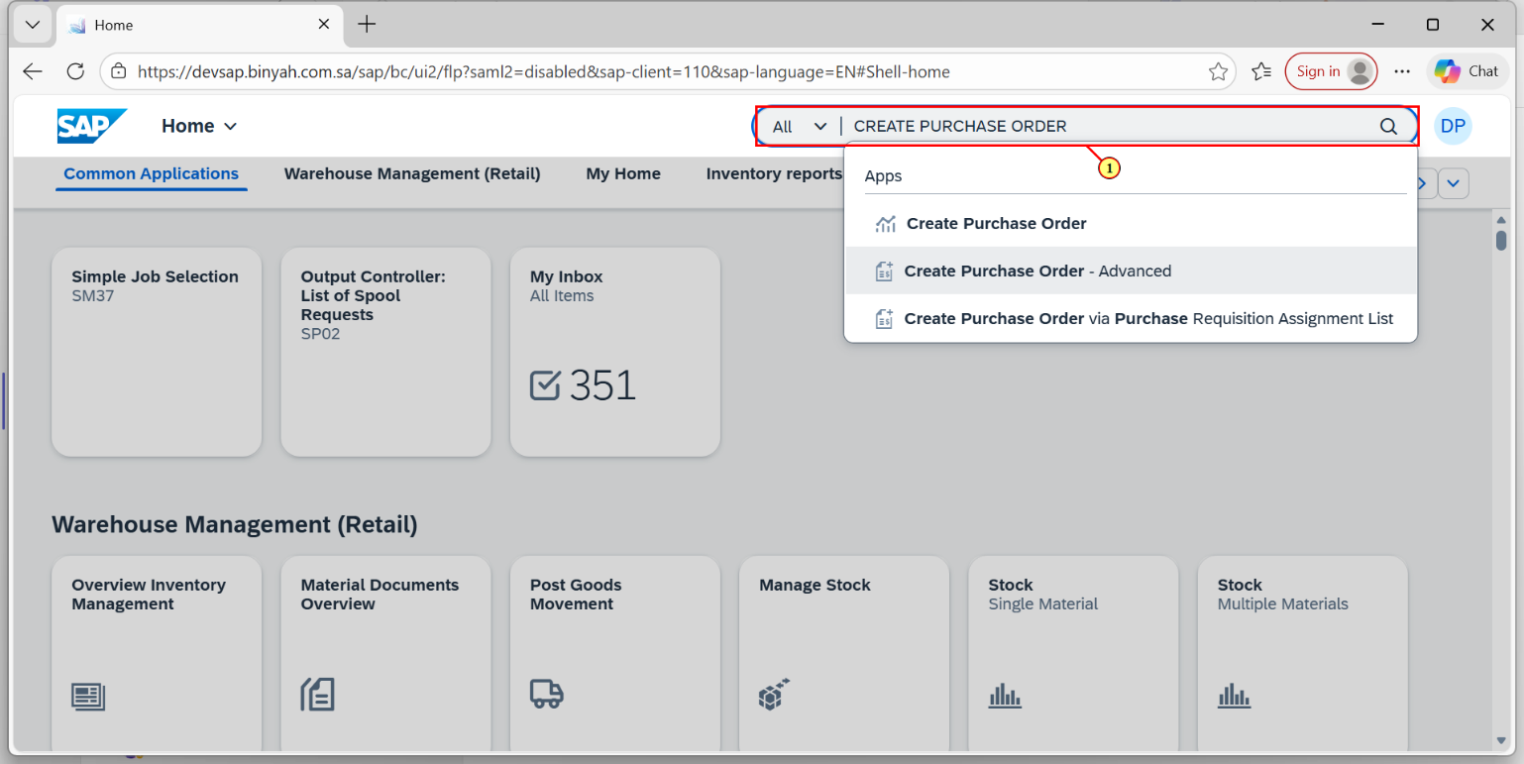

| Step | Action |
| --- | --- |
| (1) | Search and Open "Create Purchase Order-Advanced". |

Create Purchase Order - Personal - Microsoft​ Edge

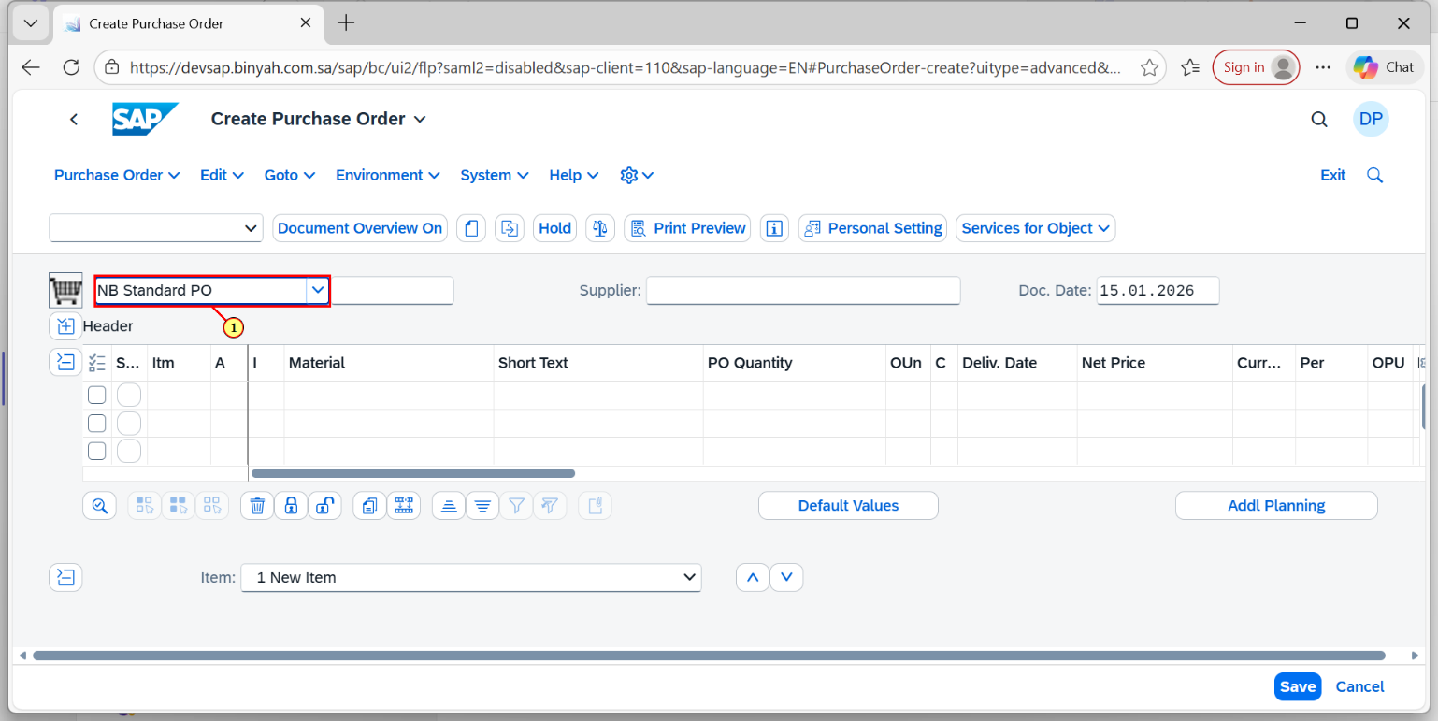

| Step | Action |
| --- | --- |
| (1) | Select the "Document Type". |

Create Purchase Order - Personal - Microsoft​ Edge

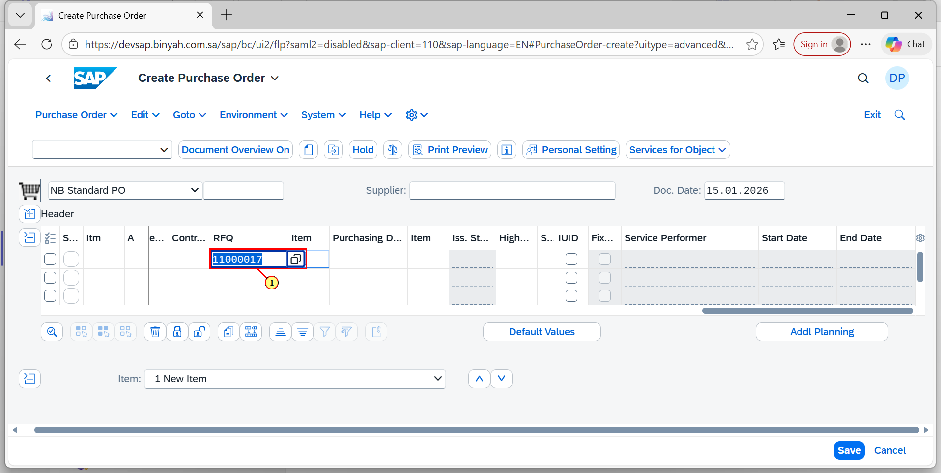

| Step | Action |
| --- | --- |
| (1) | Enter "Quotation Number " in "RFQ" field. |

Create Purchase Order - Personal - Microsoft​ Edge

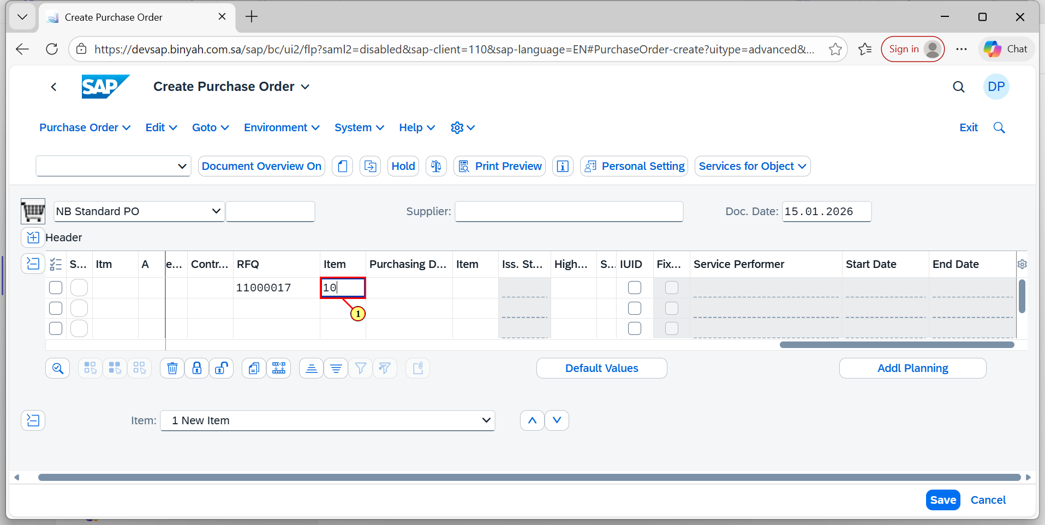

| Step | Action |
| --- | --- |
| (1) | Enter the "Quotation Item Number" in "Item" field and Press "Enter". |

Create Purchase Order - Personal - Microsoft​ Edge

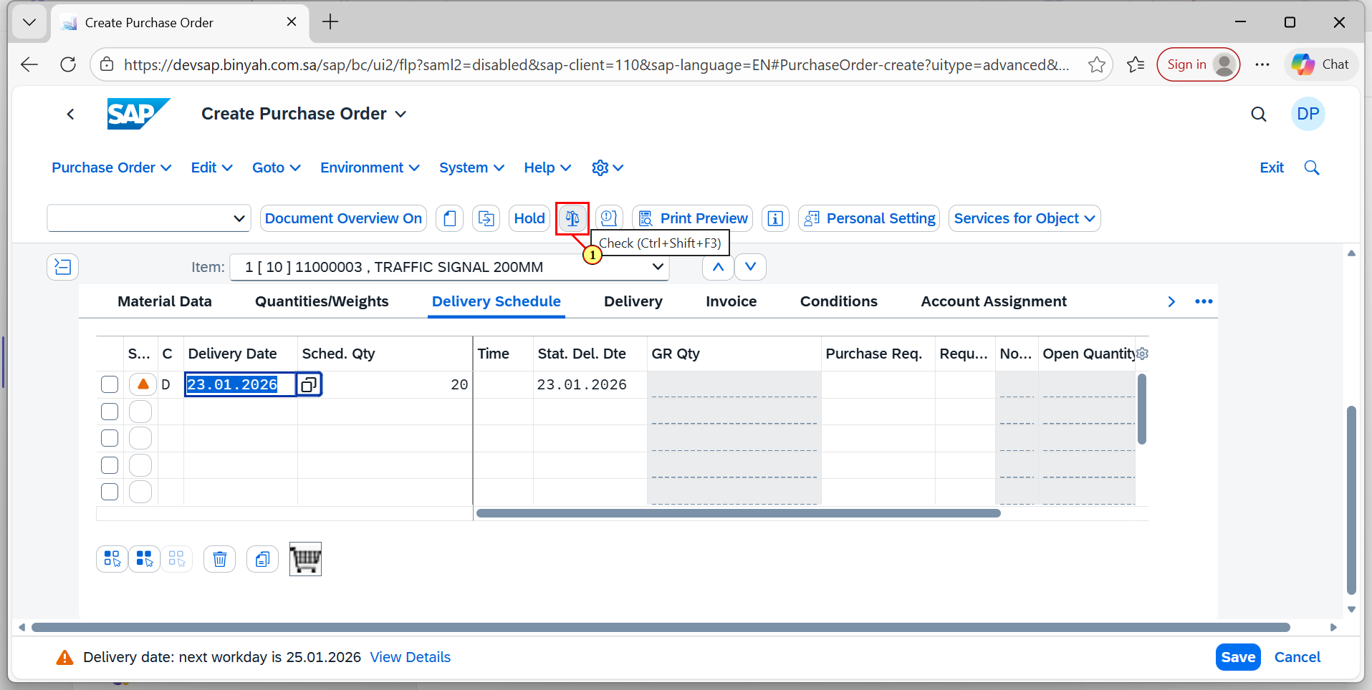

| Step | Action |
| --- | --- |
| (1) | Click on "Check". |

Create Purchase Order - Personal - Microsoft​ Edge

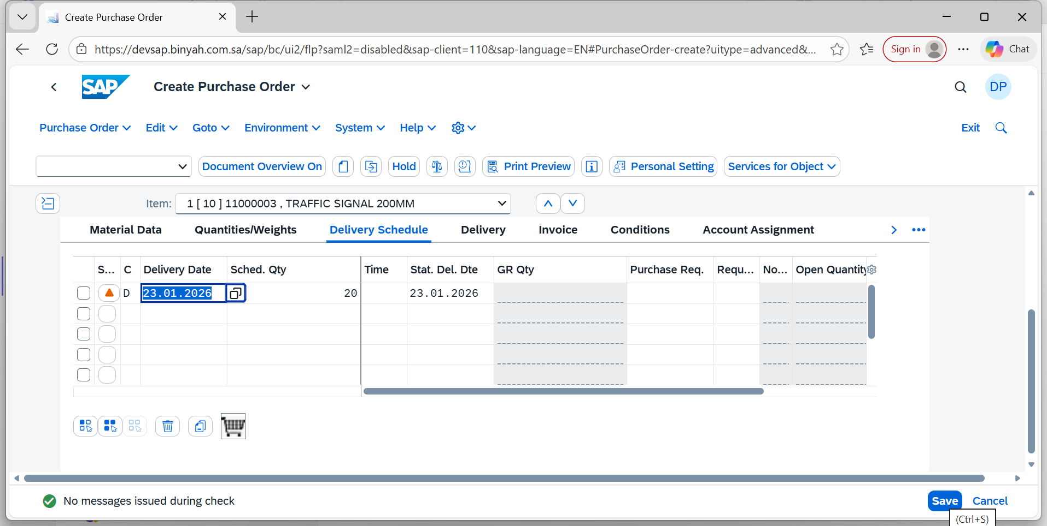

| Step | Action |
| --- | --- |
| (1) | Click on "Save". |